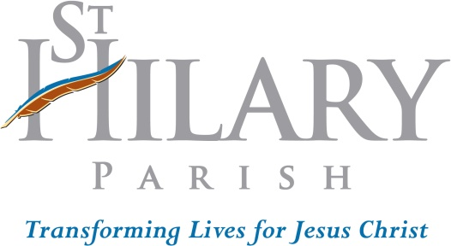
Confirmation Program
2750 W. Market St.
Fairlawn, Ohio 44333

The Advocate, the Holy Spirit whom the Father will send in my name, will instruct you in everything, and remind you of all that I told you.
I tell you all this that in me you may find peace. You will suffer in the world. But take courage! I have overcome the world.
Words of Jesus from John 14:26; 16:33
May 2023
Dear Sponsor of a St. Hilary Confirmation Candidate,

Thank you for agreeing to be a sponsor for your younger brother or sister in Christ. This life-long role says much about how the Confirmation candidate esteems your Catholic Christian lifestyle and example. To be a sponsor is both an honor and awesome responsibility, as it calls one to draw even deeper into the heart of Christ to gain wisdom in guiding the spiritual life of the candidate--now and in the future--in the ways of Christ and His Church.

After hearing that, you might be asking yourself, "What did I get myself into??" A fair question! Being a sponsor does beckon us deeper into our own relationship with the Lord. We find ourselves challenged by this: we can neither live the Christian life in the way that pleases God on our own, nor can we sufficiently guide by word and example the candidate on our own. The good news is that God does not expect us to do it alone. That is why He gave us the gift of the Holy Spirit. We simply must cooperate with the Holy Spirit. God will never call us to anything that we cannot do without His help. Let us daily ask for that help!
In order for us to keep accurate records for the diocese, we need you to fill out and sign one of the two versions of a Certificate for a Sponsor of a St. Hilary Confirmation Candidate enclosed with this letter--or one your parish supplies--and return it to us at St. Hilary Church. Complete the yellow form if you are a St. Hilary parishioner. Complete the green form if you are a parishioner at another parish; your home parish office also needs to sign the form and press their parish seal in the bottom right-hand corner of the form.

We require the candidate to meet with you at least three times before he/she is confirmed next spring.
Meeting I – DUE Oct. 9, 2023
Meeting II – DUE Dec. 4, 2023
Meeting III – DUE Spring 2024

Ideally, we’d like these meetings to take place in person but if that is not possible, please talk with the candidate on the phone or through the use of technology such as Zoom or Face Time.

(over)

During each of your meetings, the candidate is encouraged to take notes and is to write his/her reflections, summarizing the topics you discussed and reflecting how the candidate can apply what was learned to his/her own life. Please do not fill out their reflection forms for them.

-------- Save the Date --------
The Diocese has assigned us a date for celebration of your candidate’s Confirmation next spring.
Confirmation date is April 28, 2024 at 2:00 pm. The celebrant will be Bishop Martin Amos.
Also, plan to accompany your candidate to practice for the
Confirmation liturgy the day before on Saturday, April 27 at 9:25a.m.

Please keep contact with your candidate or if you have any questions at all, please feel free to call me at (330) 867-1055. Thank you for your time. May the Lord bless you for your desire for ongoing growth in Him and your lifelong prayerful and emotional support of the candidate.

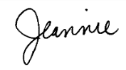
Sincerely in Christ,

Jeannie Hohlefelder
Director of Faith Formation for Children
jhohlefelder@sthilarychurch.org
Enc: Certificates for Sponsoring a St. Hilary Confirmation Candidate

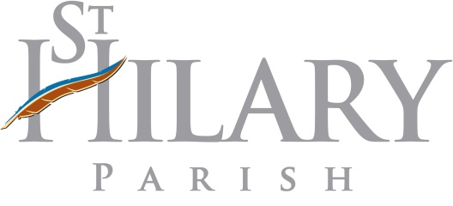
Certificate for a St. Hilary
Parishioner Sponsoring
a St. Hilary Confirmation Candidate

DUE: OCTOBER 9, 2023

NAME OF SPONSOR WHO IS A REGISTERED MEMBER OF ST. HILARY-- Please PRINT

____________________________________________________________________________________
Last Name First Name Middle I.

NAME OF CONFIRMATION CANDIDATE-- Please PRINT

____________________________________________________________________________________ Last Name First Name Middle I.

As a registered member and active member of St. Hilary Christian Community, I affirm:

  - I am a Baptized and Confirmed Catholic; if married, my marriage has been blessed by the Catholic Church;

  - I regularly participate in the Sunday Eucharistic Liturgy and give witness to my faith in Jesus Christ by taking an active part especially by receiving Communion;

  - I am striving to live out the Gospel Message in my daily life and be a support to others in so doing, especially among those who are my responsibility;

  - I am striving to grow in the knowledge and understanding of my Catholic Faith according to the opportunities opened to me (e.g. Adult Education, Scripture and spiritual reading, Parish School of Religion for youth, etc.);

  - I will give support to the person I am sponsoring for the remainder of my life by my interest in his/her Christian growth, by my prayers for him/her and by the Christian example of my life.

SPONSOR SIGNATURE ____________________________________________________________

ATTESTED BY ____________________________________________________________________
Signature of St. Hilary Parish Staff Member
DATE ___/___/___

"You will receive power when the Holy Spirit comes down on you;
then you are to be my witnesses...even to the ends of the earth."
Acts 1:8
FORM B
Dear Sponsor, Who is a Member of a Parish Other Than St. Hilary Parish,
Thank you for agreeing to be a sponsor for your younger brother or sister in Christ. This life-long role says much about how the Confirmation candidate esteems your Catholic Christian lifestyle and example. To be a sponsor is both an honor and awesome responsibility, as it calls one to draw even deeper into the heart of Christ to gain wisdom in guiding the spiritual life of the candidate in the ways of Christ and His Church. In order for us to keep accurate records for the diocese, we need you to fill out and sign this form--or one your parish supplies--and return it to us no later than Monday, OCTOBER 9, 2023, to Jeannie Hohlefelder, St. Hilary Religious Education Office, 2750 W. Market St., Fairlawn, OH 44333. If you have any questions, please call 330/867-1055 ext. 213. Thank you. May the Lord richly bless you for your service to Him and the candidate.
Certificate for a Sponsor
of a St. Hilary Confirmation Candidate

NAME OF SPONSOR--Please PRINT
__________________________________________________________________________________________
Last Name First Name Middle I.

NAME of CONFIRMATION CANDIDATE--Please PRINT
___________________________________________________________________________________________
Last Name First Name Middle I.

NAME OF CHURCH WHERE SPONSOR IS REGISTERED___________________________________

ADDRESS ________________________________________________________________________________
Number Street Name City State Zip
PHONE: _____-_____-________

As a registered and active member of my Catholic parish, I affirm:

- I am a Baptized and Confirmed Catholic; if married, my marriage has been blessed by the Catholic Church;

- I regularly participate in the Sunday Eucharistic Liturgy and give witness to my faith in Jesus Christ by taking an active part especially by receiving Communion;

- I am striving to live out the Gospel Message in my daily life and be a support to others in so doing, especially among those who are my responsibility;

- I am striving to grow in the knowledge and understanding of my Catholic Faith according to the opportunities opened to me (e.g. Adult Education, Scripture and spiritual reading, Parish School of Religion for youth, etc.);

- I will give support to the person I am sponsoring for the remainder of my life by continued interest in his/her Christian growth, by my prayers for him/her and by the Christian example of my life.

SPONSOR SIGNATURE ____________________________________________________________

ATTESTED BY ____________________________________________________________________
Signature of Pastor
Please place
DATE ___/___/___ Parish Seal here

