Who can attend CLOW?

At St. Hilary, we offer two different sections of CLOW at both the 9:00a.m. and 11:00a.m. Sunday Masses. Preschool CLOW meets in meeting room 1 (the children sit on the floor). It is for children three years old to pre-kindergarten. Our school age group meets in the choir room (meeting rooms 2 & 3) and the children are kindergarten through third grade. These two sections preschool and grade school are both led by catechists who have prepared a reflection for the day specifically for the developmental level of their audience. After third grade, children should remain in church and hear the teaching from the pulpit offered by our parish priests.
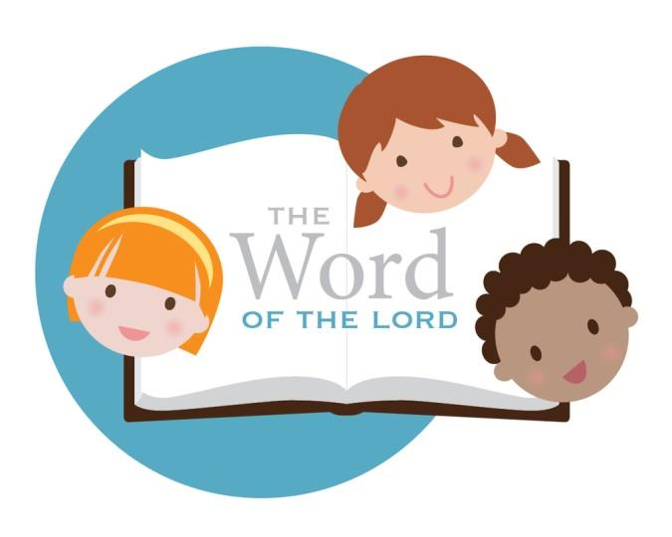

Do my children/grandchildren
have to register for CLOW?

- No, all children are welcome. Children’s Liturgy is a “drop in” session so we do not take attendance or need children registered.
- Your child does not need to attend St. Hilary School or PSR to participate either.
- Visiting cousins and grandchildren are welcome to join the CLOW children on any given Sunday.

My child won’t go to CLOW without me. What can I do to get them comfortable?

You may attend CLOW with your children to help them get accustomed to the routine. Then, after a few times attending with you, we encourage them to try going on their own. If they are not comfortable with that, maybe you could consider volunteering as a CLOW Catechist? You could serve while being with your child…win-win for all! Note, volunteers rarely serve every week. Our catechists sign up online and have resources to assist in planning the teaching for the day. Volunteers rotate and take a turn leading once or month or less.

Why is
Children’s Liturgy of the Word
(CLOW) offered?

The Vatican II document, Sacrosanctum Concilium expresses: “Mother Church earnestly desires that all the faithful should be led to that fully conscious and active participation in liturgical celebrations which is demanded by the very nature of the liturgy” (SC 14). This applies to all the faithful, including our youngest parishioners, the children of the St. Hilary. During CLOW, young children leave the sanctuary at the celebration of the Liturgy of the Word to hear the scripture readings proclaimed and explained at an age-appropriate level.

These sessions are not faith formation classes, arts-and-crafts activities, or babysitting during Mass. Rather, the children hear the same Mass readings as adults – but in simpler terms that are easier to grasp.

St. Hilary Church Children’s Liturgy of the Word

Frequently Asked Questions

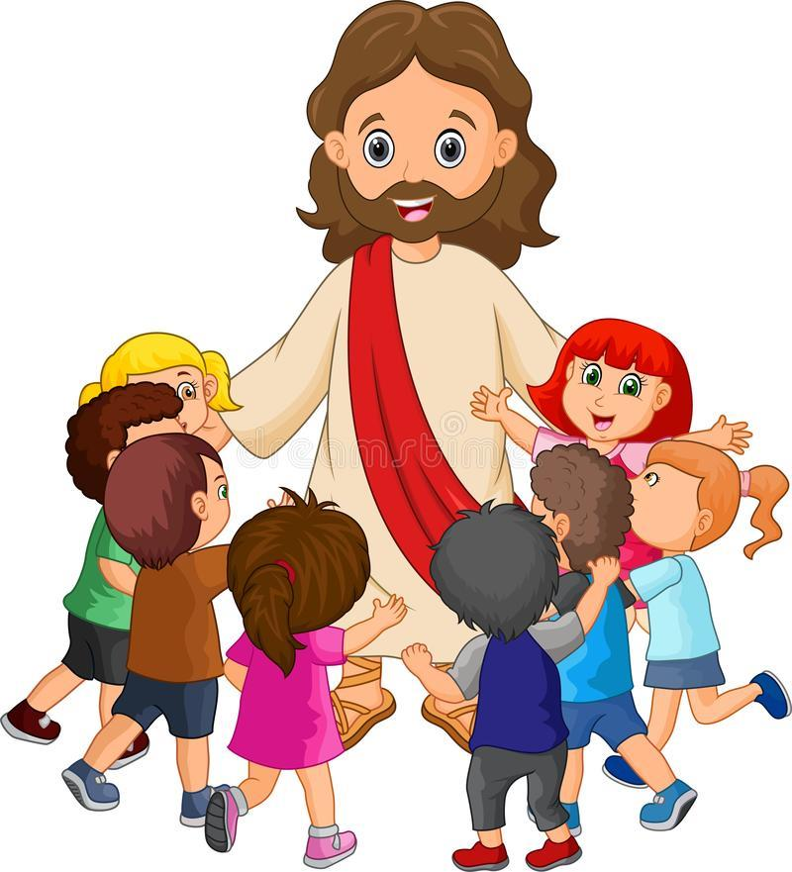

More Questions?

Contact: sthilaryparishclow@gmail.com

