

**5.14.22**

**INTO THE BREACH #12-Cornerstone**

**St. Augustine’s Prayer to the Holy Spirit**

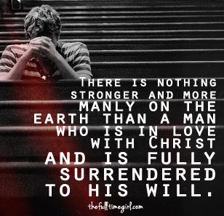**Breathe in me, O Holy Spirit, that my thoughts may all be holy. Act in me, O Holy Spirit, that my work, too, may be holy. Draw my heart, O Holy Spirit, that I love but what is holy. Strengthen me, O Holy Spirit, to defend all that is holy. Guard me, then, O Holy Spirit, that I always may be holy. Amen.**

We will complete the *Into The Breach* series today. We have discussed many topics: Masculinity, Brotherhood, Leadership, Fatherhood, Family, Life, Prayer, Suffering, Sacramental Life, Spiritual Warfare, and Evangelization. But what have you learned this past year? What are you going to take away?

This series has emphasized that to be a man who is willing and able to step into the breach requires certain commitments, including:

• Striving for a life of holiness and virtue

• Praying daily and frequently receiving the sacraments

• Fulfilling the duties of fatherhood and family life

• Supporting one’s brothers in Christ

• Serving others, especially the most vulnerable, such as the poor and unborn

• Supporting the Church, especially through the parish

Why is it important to know the purpose of your life? Many people today would be unable to articulate any thought-out answer to the question, “What is the meaning of life?” The result is widespread confusion about why we are alive and how to live.*

They are truly lost. Manhood often seems to be seen as primarily about “power,” whether it be authority and physical strength or things like one’s capacity to drink alcohol or endure hardship. Men often are tempted to think of themselves as self-sufficient and radically independent of others.*

*Into the Breach: An Apostolic Exhortation to Catholic men.

**Christ must be our Cornerstone.**

*View Knights of Columbus You Tube*

**HOLY SCRIPTURE**

**Psalms 118:20-24**

This is the Lord’s own gate, through it the righteous enter. I thank you for you answered me; you have been my savior. The stone the builders rejected has become the cornerstone. By the Lord has this been done; it is wonderful in our eyes. This is the day the Lord has made; let us rejoice in it and be glad.

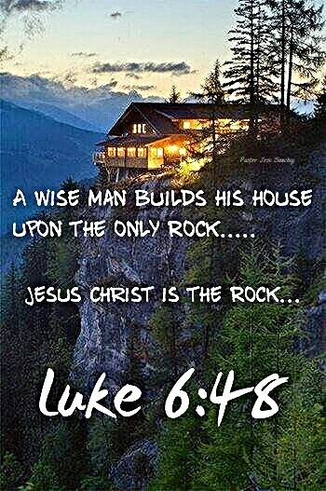

**Luke 6:46-48**

“Why do you call me, ‘Lord, Lord,’ but not do what I command? I will show you what someone is like who comes to me, listens to my words, and acts on them. That one is like a person building a house, who dug deeply and laid the foundation on rock; when the flood came, the river burst against that house but could not shake it because it had been well built.”

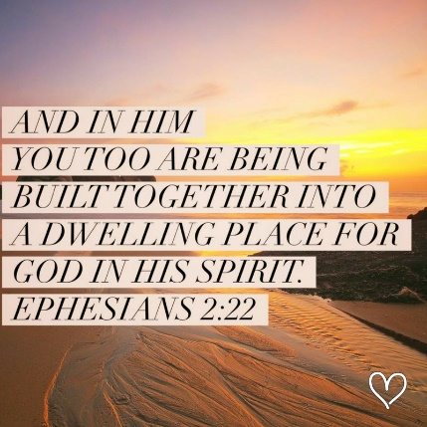**Ephesians 2:19-22**

So then you are no longer strangers and sojourners, but you are fellow citizens with the holy ones and members of the household of God, built upon the foundation of the apostles and prophets, with Christ Jesus himself as the capstone. Through him the whole structure is held together and grows into a temple sacred in the Lord; in him you also are being built together into a dwelling place of God in the Spirit. (Ephesians 2:19-22)

**Catechism**

**CCC 756 –The Church in God’s Plan**

“Often, too, the Church is called the *building* of God. The Lord compared himself to the stone which the builders rejected, but which was made into the corner-stone. On this foundation the Church is built by the apostles and from it the Church receives solidity and unity. This edifice has many names to describe it: the house of God in which his *family* dwells; the household of God in the Spirit; the dwelling-place of God among men; and, especially, the holy *temple*. This temple, symbolized in places of worship built out of stone, is praised by the Fathers and, not without reason, is compared in the liturgy to the Holy City, the New Jerusalem. As living stones we here on earth are built into it. It is this holy city that is seen by John as it comes down out of heaven from God when the world is made anew, prepared like a bride adorned for her husband.

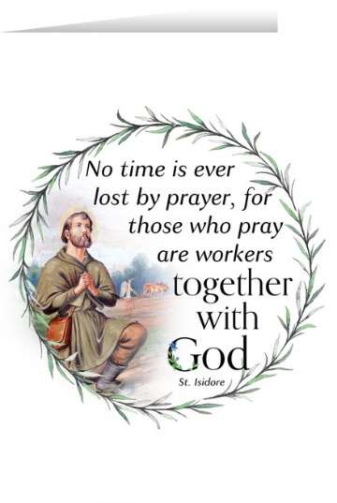**MODERN COMMENT**

**Make time for prayer.**

Matt Fradd says that it’s “just a lie that we don’t have time to pray.” You cannot make Christ the foundation of your life without regular prayer. What do you do now to “kill time” during the day or between tasks? What mindless habits or wastes of time do you engage in? Try to identify some of these things in your life—such as surfing TV channels before dinner or scrolling through social media before bed—and instead set aside that time to pray and put your focus on Christ.

**Get with the program.**

Matthew James Christoff’s call to discipline your life is necessary for any man seeking to build his life on Christ. Write down a rule or plan of life with specific actions to better and more consistently practice your faith, with a special focus on prayer and the sacraments. Make the plan challenging, but realistic—there is always room to grow. Modify it at the beginning if you find certain aspects work or don’t work for you.

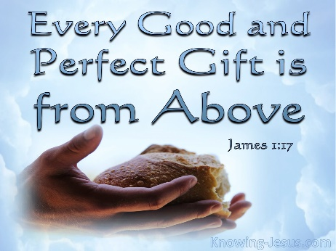**List your gifts.**

It can help us build our life on Christ by remembering what he has done for us, which is everything. Everything good in our life is a gift of God. Reflect on all the gifts God has given you and write them down. Add to the list and revisit it often. Try to focus on the positives, the good things in your life, and give thanks for them constantly.

**Finally.**

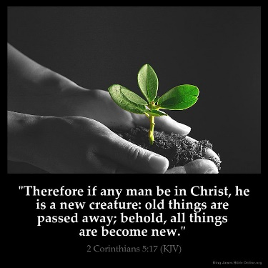“A true Catholic man stakes his whole life on this proposition—that all is made new in Jesus Christ. Our Lord has promised that He is and will always be with us. Thus, Catholic men across the centuries have responded to the call to enter the battle, ever ancient and ever new, and I have confidence that you will respond alike to fill the breach in our time. Be confident! Be bold! Forward, into the breach!” (Into the Breach: An Apostolic Exhortation to Catholic Men)

**Questions to Focus on:**

1. Many people today would be unable to articulate any thought-out answer to the question, “What is the meaning of life?” The result is widespread confusion about why we are alive and how to live. What are some of the effects of this lack of purpose in the lives of individuals and the larger society?

___________________________________________________________________

___________________________________________________________________

1. How do the lives of those who seek to know, love and serve God differ from those who seek other things in life? What are some specific and concrete things we can do to grow in the three areas of knowing, loving and serving God?

__________________________________________________________________

__________________________________________________________________

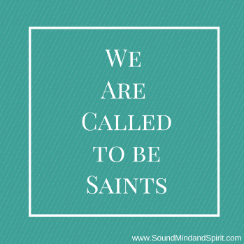

1. How can we better commit ourselves to becoming a saint and getting to heaven above all else?

___________________________________________________­­­­­­­­­­­­­

___________________________________________________

**PRAYER TO ST. MICHAEL**

St. Michael the Archangel, defend us in battle.

Be our protection againt the wickedness and snares of the Devil.

May God rebuke him, we humbly pray, and do thou,

O Prince of the heavenly hosts, by the power of God,

cast into hell Satan, and all the evil spirits,

who prowl about the world seeking the ruin of souls. Amen.

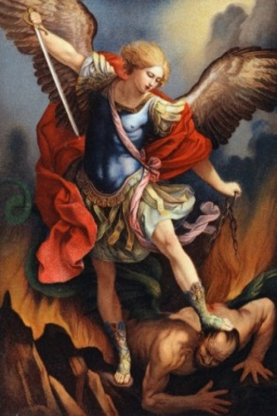

**Men’s Group Calendar**

**A man who never quits is never defeated. We are ordinary men who labor for Christ.**

5/14/2022 MEN’S GROUP 7:00 AM MASS

5/27/2022 Planning Meeting 7:45 AM Meeting Room 2 6/11/2022 MEN’S GROUP 7:00 AM MASS

**NOTE: A Rosary starts in the Reservation Chapel immediately following the meeting.**