7.9.2022

BLESSED ARE THE PEACEMAKERS

God’s Children Are They
Why do you suppose that Jesus referred to those who earn the distinction peacemaker, as children of God? Perhaps it is their child- like demeanor that can put people at ease. Or is it a certain personality trait that has the power to diminish intense discussions; find common-ground when others are searching for an out to a difficult conversation; or mix the appropriate spiritual recipe that calls for proper doses of forgiveness, compassion, and humility.

Whatever His reasons, peacemakers are “Blessed” by Jesus in the 7th Beatitude mentioned in Matthew’s Gospel verse 5: 1-12. You know the type. They may be parents who have an almost uncanny communication style that effectively puts sibling warfare out- of-business. Some politicians have the insight necessary to engage political rivals in healthy debates that earns the respect of their adversaries and the community they serve.

And one arena where peacemakers are desperately needed is youth baseball where umpires who inspire an “aura of peace” on the diamond, in the dugout, and among the fans, is rare indeed. An example of the latter is an umpire from Dayton, Ohio, who is known for controlling championship game angst by winning over the crowd during crucial calls, including balls and strikes, plays at the plate, and overall tempo of the game. I had the opportunity to witness the esteem his fellow umpires had for him moments before a state championship game was underway when another field umpire said, “You are very fortunate to have this gentleman behind the plate.” He wasn’t kidding as coaches, players, and parents, could only marvel at his peacemaking gifts.

Throughout history there have been many peacemakers known for the impact they had on their constituents, country, and the world. Some examples include: Mother Teresa, Martin Luther King Jr., and Malala Yousafzai—all winners of the Nobel Peace Prize. But the one category of Peacemakers that deserves the highest recognition, is that of the victims of Nazi terror during WWII. Edith Stein, Dietrich Bonhoeffer, Oskar Schindler, Maximilian Kolbe, and Viktor Frankl, lead the list.
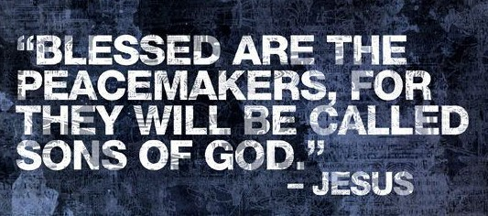
Understanding and emulating Peacemakers make the Modern World more like the Heaven we will go to when we die. Peacemakers mirror the message of the Living Christ. Understanding this Pillar of Truth improves one’s life in a dramatic and personal way to others.

Let us listen carefully to a short video on Peacemakers by Mark Leeming, and also consider the Wisdom of Holy Scripture and Catechism. May God give to each one of us the necessary means to complete His Gift of our Unique and Holy Mission.

WWW.CMFNEO.org Catholic Men’s Fellowship Website

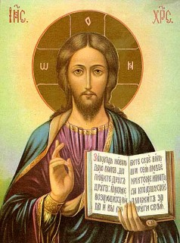
Romans 12:17-21 – Live in Peace
Do not repay anyone evil for evil; be concerned for what is noble in the sight of all. If possible, on your part, live at peace with all. Beloved, do not look for revenge, but leave room for the wrath; for it is written, "Vengeance is mine, I will repay, says the Lord."

Rather, “if your enemy is hungry, feed him; if he is thirsty, give him something to drink; for by so doing you will heap burning coals upon his head.” Do not be conquered by evil but conquer evil with good.

Romans 14:17-19 – Make Peace with All
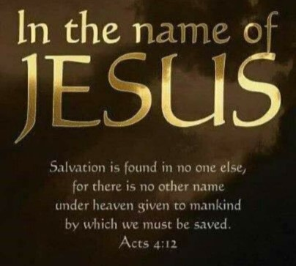
For the kingdom of God is not a matter of food and drink, but of righteousness; peace, and joy in the Holy Spirit; whoever serves Christ in this way is pleasing to God and approved by others. Let us then pursue what leads to peace and to building up one another.

Matthew 5:9 – Those Who are Blessed
Blessed are the peacemakers, for they will be called children of God. The Word of the Lord
Catechism

2304 - Peace is Indispensable for Christ’s Work
Respect for and the development of human life require peace. Peace is not merely the absence of war, and it is not limited to maintaining a balance of powers between adversaries. Peace cannot be attained on earth without safeguarding the goods of persons, free communications among men, respect for the dignity of persons and peoples, and the assiduous practice of fraternity. Peace is "the tranquility of order." Peace is the work of justice and the effect of charity.
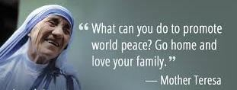

BLESSED ARE THE PEACEMAKERS

God’s Children Are They
David Eich

Edith Stein was a Jewish intellectual living in Germany when Hitler came to power. After learning her favorite college professor was a Christian, Edith began reading the writings of several Doctors of the Church. She eventually became a Catholic and entered the Carmelite Order where she took the name, Teresa Benedicta of the Cross. Eventually the future saint ended up in Auschwitz where she quickly became recognized for her compassion to those who suffered death camp horrors. She died in the gas chamber.

Maximilian Kolbe also died in Auschwitz but not before he was ordained, founded the Knights of the Immaculata, encouraged fellow prisoners to pray for their S.S. guards, and eventually traded his life for that of another condemned man. He died in a starvation bunker with ten other men on August 14th, 1941.

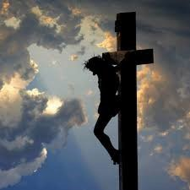
Oskar Schindler whose story was told in the movie, Schindler’s List, was credited with saving over 1100 Jews from execution in the last year of the war. Ironically, this German businessman used both cunning and peacemaking skills to convince the Nazi commandant to be merciful to his Jewish workers. This act of mercy eventually resulted in their lives being spared.

Viktor Frankl, author of the international best seller, Man’s Search for Meaning, used his Auschwitz experience to encourage optimism regardless of the tragic circumstances one is facing. One example is his story about the dying prisoner who always had a smile on his face. He told the future author: “They have taken my family, my friends, and my dignity. And I’ll be damned if I’m going to give them my attitude.”

Dietrich Bonhoeffer once wrote: “Silence in the face of evil is itself evil. God will not hold us guiltless. Not to speak is to speak. Not to act is to act.” The Lutheran pastor authored The Cost of Discipleship - based on the Sermon on the Mount. He lived his message and was eventually hanged on April 8th, 1945 for speaking out against Hitler and for the role he played in the Valkyrie plot. Six years later his bishop wrote a letter to the Bonhoeffer family where he said, “He (Bonhoeffer) was a good and saintly man. He was, without exception, the finest and most loveable man I had ever met.”

Questions for Discussion:
- Have you ever witnessed an individual that had the gift of peacemaking? Please provide examples.

- How do you reconcile Bonhoeffer’s role as a potential assassin, or Schindler’s involvement with slave labor, with the title, peacemaker? Explain.

What do you see in today’s society where situations hinder or promote peace?

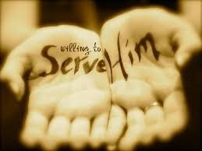
Men’s Group Calendar
A Man who never quits is Never Defeated.
We are ordinary men who labor for Christ.
7/22/22 PLANNING MEETING ROOMS 2 & 3 @ 7:45 AM
8/13/22 MEN’S GROUP MASS @ 7:00 AM
8/26/22 PLANNING MEETING ROOMS 2 & 3 @ 7:45 AM
9/10/22 MEN’S GROUP MASS @ 7:00 AM

NOTE: A rosary starts in the Reservation Chapel immediately following the meeting.

Bring Christ into the Emptiness of Our Lives

  - Spend time with Lord Jesus in Adoration. Silence fills the emptiness. Silence isn’t an absence; it’s presence.
  - Spend time with those who bring joy to life. Family, friends, church...
  - Invite Christ into your relationships. Acknowledge His presence in every moment, whether you’re alone or with others; pray together.
  - Ask God for Deeper Trust. Doubting is OK if we bring it honestly to Him. He can and will use that to bring you to a place of Deeper Trust in Him.
  - Just be in the emptiness, not running from it, not trying to fix or fill it. Letting Him love you and do the work He wants you to do.
  - Ask: What is Christ trying to teach me during this period of emptiness? How does He want me to grow from this experience?

Blessed are those that can give without remembering and take without forgetting. Give away samples of Jesus.
May God Bless You.
St. Hilary Men’s Group

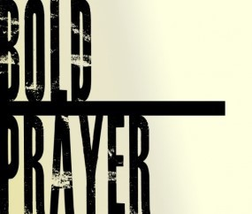
Lord, God and Savior, by your love you draw me to yourself. Forgive me – the sinner that I am, and fill me with every good thing, not withholding even the gift of your most beloved son. Come dwell in my heart.

Send forth your Holy Spirit to guide me in your path. Make me worthy of your love, and teach me how to forgive as you forgave.

Thank you for your tender mercies. I ask you to bless my family, friends and those who you put into my life. Where there is joy, give them continued joy. Where there is pain or sorrow, give them peace and mercy. Where there is doubt, release in them a renewed confidence. Fill their every need and emptiness with your Holy Grace.

You are indeed my Lord, God and Savior. Amen

